Revised MVP Summary
In summary, there has been a slight change to the app’s objective. The app will continue to allow users to upload identity documents and integrate their bank accounts, integrate with ATO and Equifax. Users will still be able to access their credit score and credit history retrieved from Equifax and find loan matches based on their selected loan type, amount, purpose and duration. However, the app will no longer facilitate the creation or submission of loan applications. Instead, users will be able to express interest in suitable loan products and view their past enquiries, including details of the lenders to whom they expressed interest.
For the Master Admin portal, the existing functionality will remain largely unchanged, except that Application Management will be replaced with Enquiry Listings. When a customer expresses interest in a loan, their identity information, bank summary, ATO summary, credit score, credit history and selected loan requirements—including the amount, purpose and duration—will be sent to the relevant lender’s secure email address, which will be provided by the client. Post-MVP, lender CRM integrations will be introduced so this information can be shared directly with each lender’s CRM. The app level detail is as follows:

Design screen

Mobile App

- Register https://www.figma.com/design/6SsjQCK4trrRIbxF956pEG/Sara-app?node-id=66-4014&t=8r3m6RVORcsdwXbI-4
- Login https://www.figma.com/design/6SsjQCK4trrRIbxF956pEG/Sara-app?node-id=66-4015&t=8r3m6RVORcsdwXbI-4
- Forgot Password: https://www.figma.com/design/6SsjQCK4trrRIbxF956pEG/Sara-app?node-id=66-4016&t=8r3m6RVORcsdwXbI-4
- Biometric login https://www.figma.com/design/6SsjQCK4trrRIbxF956pEG/Sara-app?node-id=66-4017&t=8r3m6RVORcsdwXbI-4
- Notification: https://www.figma.com/design/6SsjQCK4trrRIbxF956pEG/Sara-app?node-id=66-4018&t=8r3m6RVORcsdwXbI-4
- Verify you identity https://www.figma.com/design/6SsjQCK4trrRIbxF956pEG/Sara-app?node-id=66-4019&t=8r3m6RVORcsdwXbI-4
- Household information
- Add Bank Account: https://www.figma.com/design/6SsjQCK4trrRIbxF956pEG/Sara-app?node-id=85-6045&t=8r3m6RVORcsdwXbI-4
- Connected ATO:https://www.figma.com/design/6SsjQCK4trrRIbxF956pEG/Sara-app?node-id=85-7020&t=8r3m6RVORcsdwXbI-4
- Additional Household information: https://www.figma.com/design/6SsjQCK4trrRIbxF956pEG/Sara-app?node-id=102-3699&t=8r3m6RVORcsdwXbI-4
- Equifax Connection: https://www.figma.com/design/6SsjQCK4trrRIbxF956pEG/Sara-app?node-id=102-3700&t=8r3m6RVORcsdwXbI-4
- Dashboard:
a.https://www.figma.com/design/6SsjQCK4trrRIbxF956pEG/Sara-app?node-id=1031-34841&t=8r3m6RVORcsdwXbI-4 :
- Remove the Financial Overview and Serviceability sections.
- Add a new Recent Enquiries section displaying the user’s latest expressions of interest submitted to lenders.
- Each enquiry should display:
  - Loan type
  - Date
  - Loan amount
  - Loan purpose and duration
  - All lenders to whom the user submitted an expression of interest
- Display the two or three most recent enquiries on the dashboard.
- Include a View All option that redirects the user to the Enquiries Listing page.
B. Financial Tools: 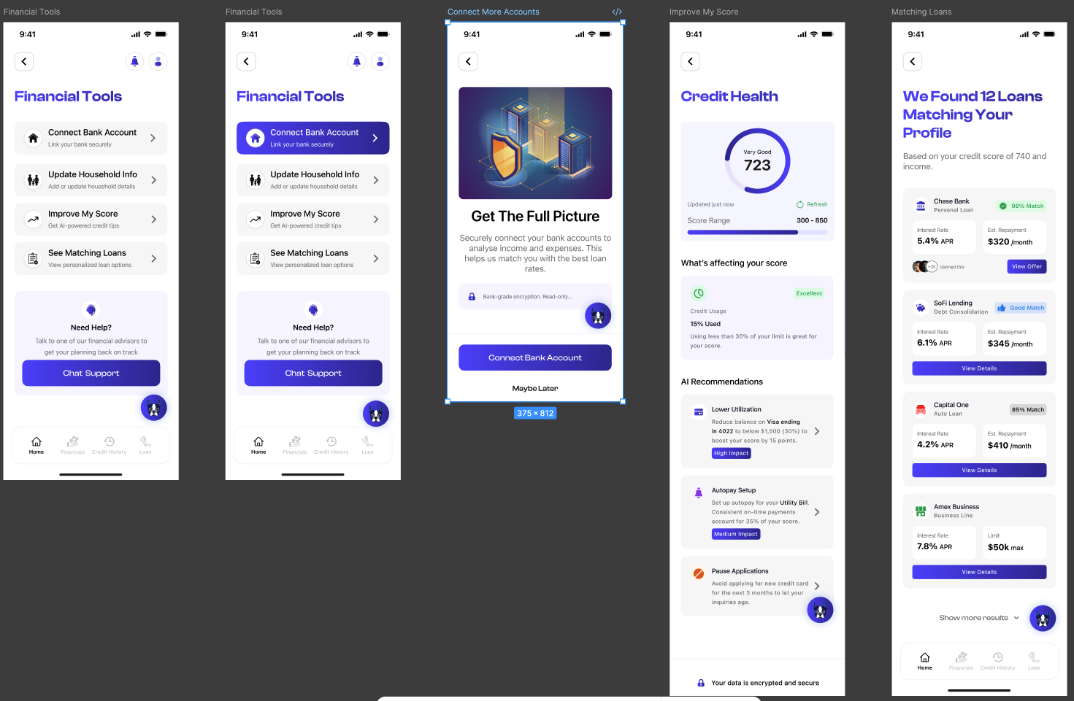
C. AI Financial Coach
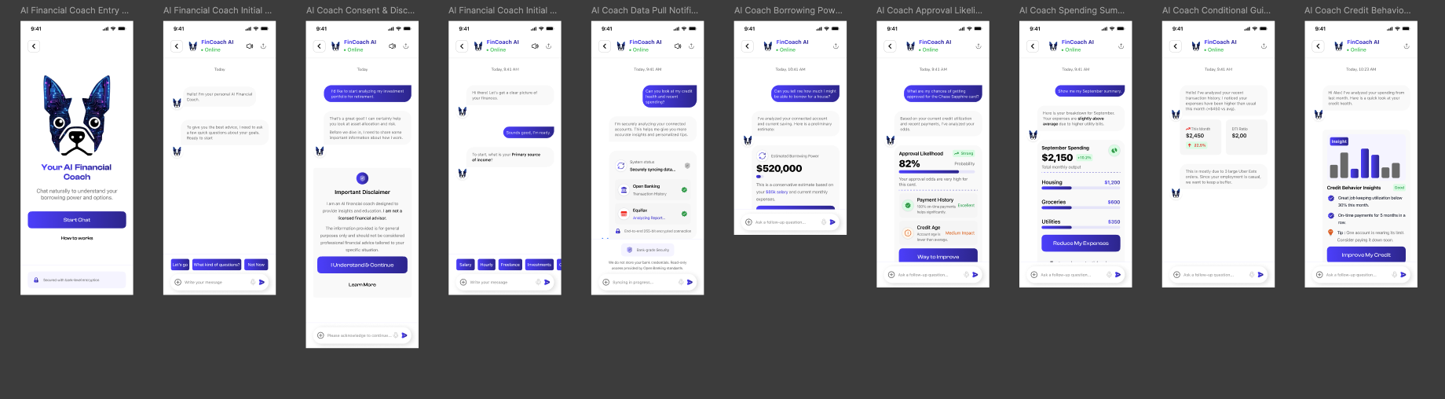
- Connected Financial: https://www.figma.com/design/6SsjQCK4trrRIbxF956pEG/Sara-app?node-id=233-2648&t=8r3m6RVORcsdwXbI-4
- Credit History
  - Credit Overview: https://www.figma.com/design/6SsjQCK4trrRIbxF956pEG/Sara-app?node-id=266-2596&t=8r3m6RVORcsdwXbI-4 . Remove Income Summary. Expense & Liabilities and Serviceability and Financial Overview
  - Credit score Review https://www.figma.com/design/6SsjQCK4trrRIbxF956pEG/Sara-app?node-id=1122-23740&t=8r3m6RVORcsdwXbI-4
  - Credit History: https://www.figma.com/design/6SsjQCK4trrRIbxF956pEG/Sara-app?node-id=266-3997&t=8r3m6RVORcsdwXbI-4
- Loan
  - Loan finder https://www.figma.com/design/6SsjQCK4trrRIbxF956pEG/Sara-app?node-id=221-2138&t=8r3m6RVORcsdwXbI-4, https://www.figma.com/design/6SsjQCK4trrRIbxF956pEG/Sara-app?node-id=222-2316&t=8r3m6RVORcsdwXbI-4
  - Loan search result , more loan option and loan detail: https://www.figma.com/design/6SsjQCK4trrRIbxF956pEG/Sara-app?node-id=223-2439&t=8r3m6RVORcsdwXbI-4 : Replace the Select Loan button with Express Interest. When a customer clicks Express Interest, the enquiry should be added to the Enquiries Listing page. The relevant lenders will receive a list of interested customers, including each customer’s loan requirements—loan purpose, amount and duration—as well as their identity details and supporting documents, bank summary, ATO summary, credit score and credit history.
https://www.figma.com/design/6SsjQCK4trrRIbxF956pEG/Sara-app?node-id=231-2204&t=8r3m6RVORcsdwXbI-4
Loan detail: https://www.figma.com/design/6SsjQCK4trrRIbxF956pEG/Sara-app?node-id=224-2932&t=8r3m6RVORcsdwXbI-4 . Replace Continue with This loan with Express Interest
  - Past Enquiries
Add a new Past Enquiries page displaying all enquiries submitted by the user. Enquiries should be sorted by date, with the most recent displayed first.
Each enquiry should display:
- Loan type
- Loan Purpose
- Loan amount
- Duration
- Enquiry date
- All lenders to whom the user submitted an expression of interest
When the user selects an enquiry, they should be taken to the Enquiry Details page.
  - Enquiry Details
The Enquiry Details page should display the list of lenders for that specific enquiry. This should include all lenders the user expressed interest in and with whom the user’s details were shared.
- Profile and Settings: https://www.figma.com/design/6SsjQCK4trrRIbxF956pEG/Sara-app?node-id=409-5872&t=8r3m6RVORcsdwXbI-4

Master Admin:
- Project Setup
- Authentication
- Dashboard
- Users Management
- Lender Management
- Loan Product Management: for each product will have to have a list of enquiries and detail of the customers inquiring about the product.
- Promotion Management
- Application Management Enquiry Listing Page
The Enquiry Listing page should be organised by loan type. Within each loan type, display the product-specific enquiries received.
  - Each enquiry in the listing should display:
  - Customer name
  - Loan purpose
  - Loan amount
  - Enquiry date
  - View detail CTA

Enquiry Details Page
  - When the Master Admin selects an enquiry, the Enquiry Details page should display the customer’s complete profile, including:
  - Personal and identity details
  - Banking details
  - ATO information
  - Credit information
  - Loan purpose
  - Requested loan amount
  - Enquiry date
  - Alternatively, Can by pass to the Customer detail in Customer management
- CMS Management
- Audit Logs
- Notifications Center

